Week 5 Task – Performance Optimization and Interactive Feature Enhancement
Sales Performance & Growth Opportunities Dashboard
Prepared by: Mukesh Samarit
Course / Module: Virtual Tableau Visualization Intern
Date: 29 August 2026

1. Objective and Scope
The objective of this task is to optimize the existing Tableau dashboard for performance, scalability, and enhanced interactivity. Building on the advanced visualizations and calculated fields developed in Weeks 2–4, this phase focuses on ensuring that the dashboard remains responsive as data volume grows, while also improving user engagement through intuitive interactive features.
The scope includes:
- Assessing the current (hypothetical) dashboard design for performance bottlenecks.
- Defining practical optimization strategies for data processing, calculations, and visualization design.
- Proposing interactive enhancements such as dynamic filters, drill-down capabilities, and parameter controls.
- Documenting all steps, recommendations, and expected outcomes in a comprehensive DOC file.

2. Assessment of Current Dashboard Performance

2.1 Hypothetical Dashboard Context
The dashboard under consideration is the “Sales Performance & Growth Opportunities – Advanced Analytics” dashboard developed in previous weeks. It includes:
- A dual-axis chart (Revenue + Avg Discount by Month).
- A heat map (Region × Product Category with Avg Customer Rating).
- Supporting views: revenue by region (bar and pie charts), scatter plot (Delivery vs Customer Rating), and a detail table with Delivery Performance Flag.
- Global filters for date, region, product category, and payment method.
For the purpose of this task, we assume the underlying dataset has grown significantly (e.g., multiple years of orders, thousands of SKUs, and millions of rows), leading to potential performance issues.

2.2 Identified Performance Bottlenecks
Based on typical Tableau behavior with growing data, the following bottlenecks are anticipated:
- Live Connection to Large Dataset
  - Using a live connection to a large CSV/Excel file or database can cause slow query execution, especially for complex aggregations and table calculations.
- Heavy Use of Table Calculations
  - Calculations like Month-over-Month Revenue % Change, if computed over large partitions, can increase rendering time.
- Multiple High-Detail Views on One Dashboard
  - Having several detailed charts and a full detail table on a single dashboard can increase the number of marks rendered, slowing down load and interaction times.
- Inefficient Filter Design
  - Filters applied after heavy computations (instead of early in the data pipeline) can cause unnecessary processing.
- Complex Calculated Fields
  - Multiple calculated fields, especially those using FIXED level-of-detail (LOD) expressions, can add overhead if not optimized.
- Lack of Data Extract Optimization
  - If using Tableau extracts (.hyper), they may not be optimized (e.g., no aggregations, unused columns not removed), leading to larger file sizes and slower performance.

3. Performance Optimization Strategies
This section outlines practical strategies to improve dashboard performance in Tableau.

3.1 Data Source Optimization
1. Use Tableau Data Extracts (.hyper)
- Convert the live connection to a Tableau extract.
- Benefits:
  - Faster query performance due to optimized storage and indexing.
  - Ability to apply extract-specific optimizations (aggregations, filters).
2. Filter Data at Extract Level
- Apply relevant filters during extract creation, such as:
  - Date range (e.g., last 2–3 years instead of all historical data).
  - Exclude irrelevant regions or categories if not needed for the primary audience.
- This reduces the number of rows loaded into memory.
3. Remove Unused Columns
- In the extract, hide or remove columns that are not used in any calculation or visualization (e.g., internal IDs, debug fields).
- Smaller extracts lead to faster loading and lower memory usage.
4. Aggregate Data Where Possible
- For high-level summary views (e.g., monthly revenue), consider creating an aggregated extract at the month level in addition to the detailed extract.
- Use this aggregated source for the dual-axis chart to reduce computation.

3.2 Calculation Optimization
1. Optimize Level-of-Detail (LOD) Expressions
- Review FIXED LOD expressions (e.g., monthly revenue) and ensure they are necessary.
- Where possible, replace with simpler aggregations or context filters.
2. Limit Use of Complex Table Calculations
- For MoM Revenue % Change:
  - Ensure the calculation is computed only on necessary partitions (e.g., by month, not by every dimension).
  - Avoid applying table calculations on very granular views (e.g., order-level detail).
3. Precompute Flags and Categories
- For Delivery Performance Flag, consider precomputing this in the data source (ETL layer) if the threshold is stable.
- This reduces runtime calculation overhead.

3.3 Visualization and Dashboard Design Optimization
1. Reduce Number of Marks
- Limit the detail level in views:
  - Use aggregated views (by month, region, category) instead of order-level detail.
  - Avoid showing extremely granular detail tables on the main dashboard; move them to a separate “Detail” sheet if needed.
2. Simplify Complex Charts
- Evaluate whether all five main views are needed on the primary dashboard.
- Consider:
  - Removing the pie chart if the bar chart already shows revenue by region clearly.
  - Moving the scatter plot or detail table to a separate dashboard tab.
3. Use Context Filters Strategically
- For frequently used filters (e.g., Region, Product Category), set them as context filters.
- This ensures that other filters and calculations are applied after the data is already reduced, improving performance.
4. Limit Use of High-Resolution Maps and Heavy Formatting
- While not heavily used in this dashboard, avoid unnecessary heavy formatting, custom shapes, or map layers that can slow rendering.

3.4 Expected Performance Improvements
By implementing the above strategies, the following improvements are expected:
- Faster initial load time of the dashboard (especially when opening the workbook or switching tabs).
- Smoother filter interactions, with reduced lag when changing date ranges, regions, or categories.
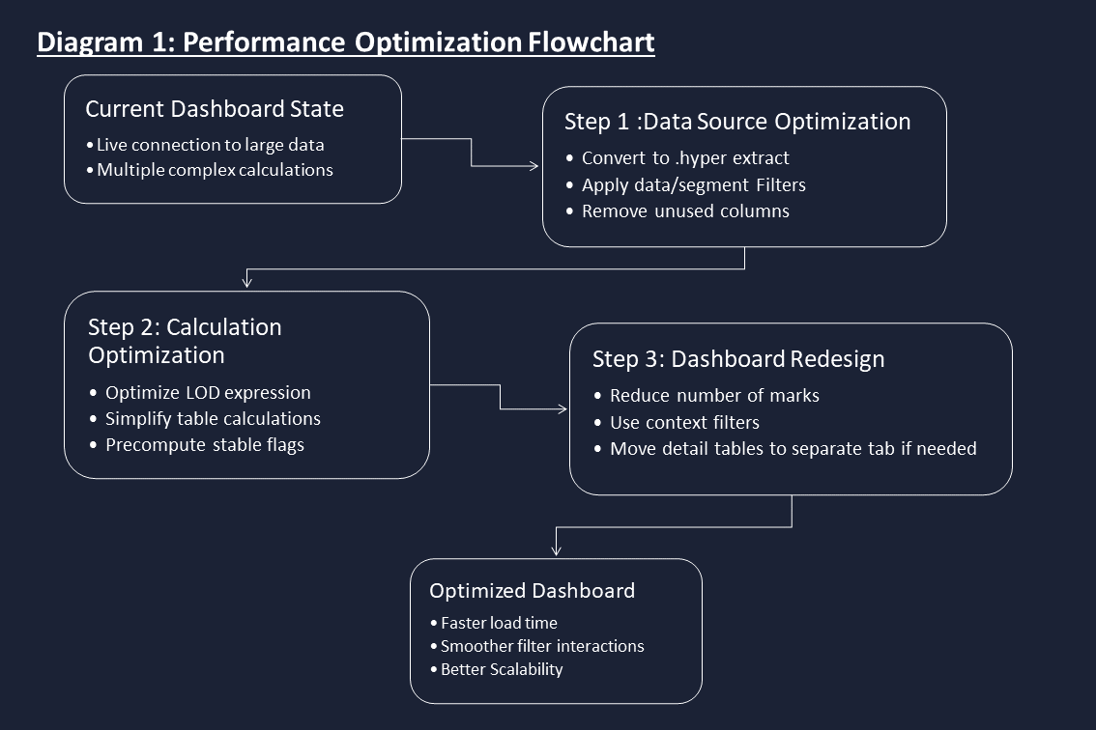
- Better scalability, allowing the dashboard to handle larger datasets without significant degradation in performance.

4. Enhancing Interactivity and User Engagement
In addition to performance, this phase focuses on making the dashboard more interactive and user-friendly.

4.1 Dynamic Filters and Parameter Controls
1. Date Range Parameter
- Introduce a parameter for “Analysis Period” (e.g., Last 3 Months, Last 6 Months, Last 12 Months, Year-to-Date).
- Use this parameter in a calculated field to filter order_date.
- Benefit: Users can quickly switch time horizons without manually adjusting date filters.
2. Metric Selector Parameter
- Add a parameter that allows users to choose which metric drives the heat map color:
  - Avg Customer Rating
  - Avg Delivery Days
  - Avg Discount %
- Use a calculated field that references this parameter to dynamically change the color measure.
- Benefit: A single heat map can serve multiple analytical questions.
3. Performance Threshold Parameter
- For Delivery Performance Flag, allow users to adjust the threshold (e.g., “Good” if ≤ 3, 4, or 5 days).
- Implement this via a parameter used in the Delivery Performance Flag calculation.
- Benefit: Different teams (e.g., logistics vs. management) can define “good” delivery according to their own standards.

4.2 Drill-Down Capabilities
1. Region → Category → Product Drill-Down
- Create a hierarchy: Region → Product Category → (optionally) Product Sub-Category or Product Name.
- Enable users to:
  - Click on a region in the heat map or bar chart to drill down into categories within that region.
  - Further drill into specific products if needed.
- Implementation:
  - Use Tableau’s hierarchy feature and enable “Show Drill-Down” in the view.
- Benefit: Users can start high-level and progressively explore details without cluttering the main dashboard.
2. Time-Based Drill-Down
- Create a hierarchy: Year → Quarter → Month → Week.
- Allow users to drill from yearly revenue trends down to monthly or weekly patterns.
- Benefit: Better identification of seasonal patterns and short-term anomalies.

4.3 Dashboard Actions for Enhanced Interactivity
1. Filter Actions from Heat Map
- Configure a filter action such that:
  - Clicking on a cell in the heat map (Region × Product Category) filters the dual-axis chart and other views to that specific combination.
- Benefit: Users can analyze revenue and discount trends for a specific segment directly.
2. Highlight Actions
- Set up highlight actions so that:
  - Hovering over a region in the bar chart highlights corresponding cells in the heat map and related rows in the detail table.
- Benefit: Easier cross-view comparison without applying hard filters.
3. URL Actions (Optional)
- If there is an external reporting system or detailed operational dashboard, configure URL actions to:
  - Open a detailed report for a selected region or product category when double-clicked.
- Benefit: Links high-level insights to operational deep-dives.

4.4 User Guidance and Intuitive Design
1. Clear Labels and Instructions
- Add brief text captions on the dashboard explaining:
  - How to use the metric selector parameter.
  - How to interpret the heat map colors.
  - What the Delivery Performance Flag indicates.
2. Consistent Color Schemes
- Use consistent colors for:
  - “Good” vs “Poor” delivery performance across all views.
  - Revenue and discount in the dual-axis chart.
- Benefit: Reduces cognitive load and improves interpretability.
3. Logical Layout and Grouping
- Group related visualizations together (e.g., time-based views at the top, segment-based views in the middle, detail tables at the bottom).
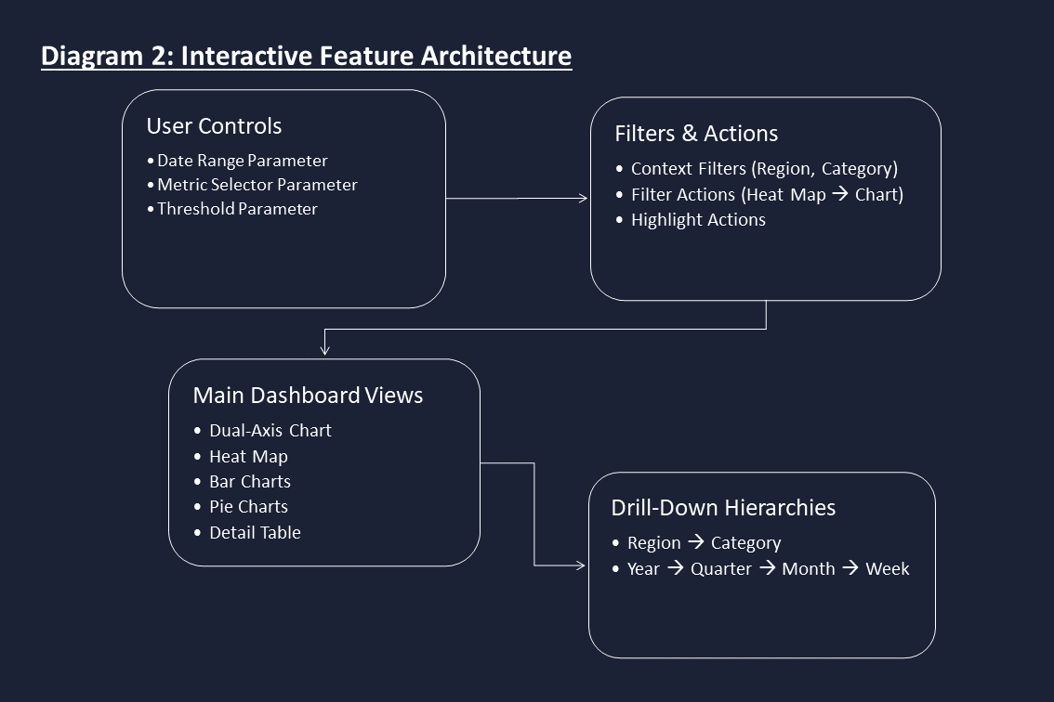
- Ensure filters are placed prominently and labeled clearly.

5. Implementation Plan

5.1 Phase 1 – Data and Calculation Optimization
- Convert data source to an optimized .hyper extract.
- Apply date and segment filters at the extract level.
- Remove unused columns.
- Review and optimize LOD expressions and table calculations.
- Precompute stable flags (e.g., Delivery Performance Flag) if feasible.

5.2 Phase 2 – Dashboard Redesign for Performance
- Reduce the number of high-detail views on the main dashboard.
- Move detailed tables to a separate “Detail” tab if necessary.
- Set key filters (Region, Product Category) as context filters.
- Test dashboard load times and filter responsiveness after changes.

5.3 Phase 3 – Interactive Feature Enhancement
- Implement parameters for:
  - Analysis Period (date range).
  - Heat map metric selector.
  - Delivery performance threshold.
- Configure hierarchies for drill-down (Region → Category; Year → Month).
- Set up filter and highlight actions between heat map, dual-axis chart, and supporting views.
- Add brief instructional text on the dashboard for new users.

5.4 Phase 4 – Testing and Validation
- Test with different data volumes (e.g., last 6 months vs last 3 years).
- Validate that:
  - Load times are acceptable (e.g., under 3–5 seconds for main dashboard).
  - Filter and parameter changes respond smoothly.
  - Drill-down and actions work as intended without breaking calculations.

6. Expected Outcomes
By implementing the strategies outlined above, the following outcomes are expected:
- Improved Performance
  - Faster dashboard load and interaction times, even with larger datasets.
  - More efficient use of system resources due to optimized extracts and calculations.
- Enhanced User Experience
  - Intuitive controls (parameters, dynamic filters) that allow users to customize their view.
  - Drill-down capabilities that support both high-level and detailed analysis without clutter.
- Scalability
  - A dashboard design that can accommodate future data growth and additional metrics without major rework.
- Better Decision Support
  - Clearer, faster access to insights on revenue trends, discount impact, delivery performance, and customer satisfaction.
  - Interactive features that enable users to ask and answer their own questions directly within the dashboard.

7. Conclusion
This optimization and interactivity enhancement plan ensures that the “Sales Performance & Growth Opportunities” dashboard is not only analytically rich but also performant and user-friendly. By combining technical improvements (extracts, optimized calculations, reduced complexity) with thoughtful interactive features (parameters, drill-downs, actions), the dashboard becomes a robust decision-support tool for the marketing and operations teams. The documented strategies provide a clear roadmap for implementation and future scaling as business needs evolve.

